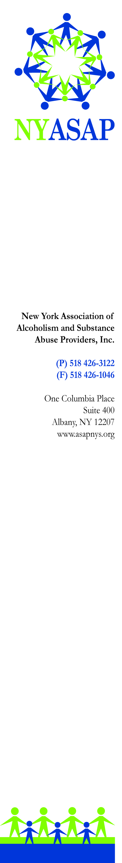
Addressing a Public Health Crisis
Investment Needed for Prevention, Treatment, and Recovery Support

As New York State families and communities continue to be impacted by the epidemic of prescription opiate and heroin overdose, Combat Heroin, a media campaign recently launched to prevent the escalation of this epidemic, offers hope and anticipation that New York will meet the challenge posed by this crisis. The New York Association of Alcoholism and Substance Abuse Providers calls upon Governor Cuomo and the NYS Legislature to provide resources to strengthen prevention, treatment, and recovery support services.

Infrastructure to Support Implementation of Healthcare Reform and Medicaid Redesign
Substance use disorders prevention, treatment, and recovery support services are ill-equipped to transform their business operations for managed care, integration with mental health and primary care, and healthcare reform. Many programs do not have electronic health records or other business infrastructure that will be necessary to survive in the near future. Using a portion of the $4.2 billion settlements that the Attorney General and the Department of Financial Services reached with five institutions, ASAP asks the Governor to include funding in his Executive budget for important one time expenditures:
To the OASAS budget, add funding:
- To support business and service delivery transformation to facilitate implementation of Medicaid redesign and healthcare reform in prevention, treatment, and recovery support programs (electronic health records, billing infrastructure, etc.)
- For technical assistance for behavioral health business transformation projects
- For residential redesign

Using an investment of new resources to address the epidemic of overdose and substance use disorders, we advocate for:
Support for our Workforce
We must address the low wages of our workforce and reduce staff turnover. An unstable and underpaid workforce will seriously impede the ability of service providers to meet community needs and healthcare reform requirements.
ASAP asks the Governor to include funding in his Executive budget to support our workforce.

Resources for Prevention
Support for prevention has been declining for decades. Congress eliminated the Safe and Drug Free Schools Program. The number of prevention counselors in our schools is less than it was two decades ago and community prevention programs are shrinking. It is time to reverse the decline in support for prevention.
ASAP asks the Governor to include funding in his Executive budget to support school-based prevention and early intervention/student assistance services and to enhance community-based prevention services.

Resources for Treatment
Treatment is not accessible for adolescents and young adults in every region of the state. Specialized services for veterans, persons addicted to opiates, persons needing intensive outpatient services, or persons needing residential/inpatient treatment are also hard to access across the state. ASAP asks the Governor to include funding in his Executive budget to strengthen treatment and make it accessible on demand. We ask that funding be allocated:
- To expand adolescent treatment
- To expand Young Adult Treatment
- For Veterans’ Treatment
- To strengthen medication assisted treatment
- To strengthen Outpatient Services

Resources for Recovery Support
Recovery Centers should be located in every NYS County with emphasis on accessibility to recovery support and peer services. Urban, suburban, and rural counties will each develop a Recovery Support Plan and strategically place Recovery Support Centers so that there is accessibility for recovering persons and their families. To the OASAS budget, add:
ASAP asks the Governor to include funding in his Executive budget to support establishment of new recovery support centers

Resources to Address Need for Problem Gambling Services
As New York embarks on expansion of gambling in communities across the State, ASAP asks the Governor to include funding in his Executive budget to support problem gambling prevention, treatment, and recovery services.

